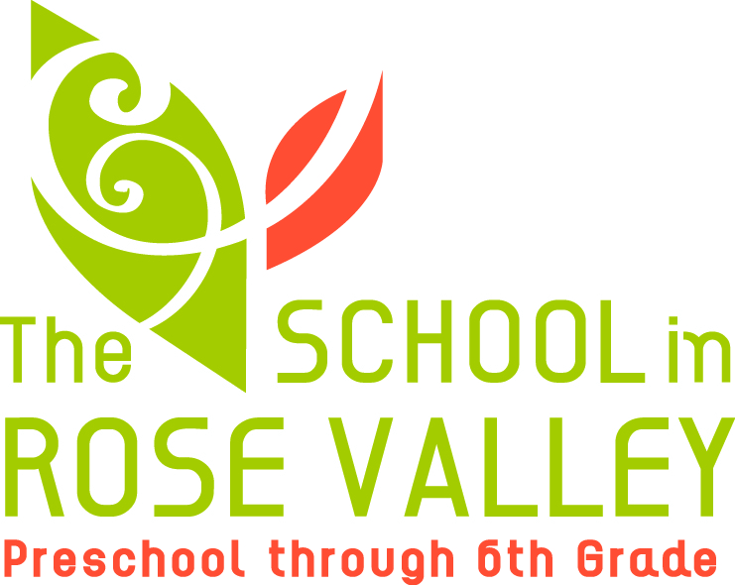

The School in Rose Valley (SRV), a progressive preschool through sixth-grade program, founded in 1929, seeks a 5th- and 6th-grade teacher for the 2018-19 school year. This is a unique, exciting opportunity for a passionate teacher who wants to work with the oldest students at a well-established institution that remains true to its progressive roots.
Qualified candidates will have at least a bachelor’s degree and at least five years of teaching experience. Candidates must have experience with and a thorough understanding of progressive education, project-based learning, democratic classrooms, and emergent curriculum. A strong understanding of childhood development as well as middle childhood and adolescent education is essential. Candidates must also possess the ability to communicate effectively, both verbally and in writing, and the ability to establish and maintain effective working relationships with students, staff, parents, and the public.
SRV’s Mission: In our classrooms and our wooded campus, teachers and students create experiences that arouse curiosity, stretch muscles, strengthen initiative, and stimulate questions. We guide children to know themselves, to delight in learning, and to understand their opportunities and responsibilities in our community and the world.
For more information see: www.theschoolinrosevalley.org.
To apply, please send cover letter specifying how your interests and experiences fit with our mission and your resume to: Kj Weist, Office Manager, 20 School Lane, Rose Valley, PA 19063 or kj@theschoolinrosevalley.org.
Search will commence immediately and will continue until the position is filled.

20 School Lane, Rose Valley PA 19063 ● theschoolinrosevalley.org ● t: 610.566.1088 f: 610.566.4640

